

Permit Reference:  As Varied by: | P11/18

ENVIRONMENTAL PERMIT

Pollution Prevention and Control Act 1999

Environmental Permitting (England and Wales) Regulations 2016

as amended

Operator  RBK Services Ltd  2 Hurstfield  Bromley  Kent  BR2 9BB  Address of Permitted Activity  Shay Service Station  Newtown Road  Ramsey  Peterborough  PE26 1EJ | Registered Office  T&K Accounting Group  69 Banstead Road  Carshalton  SM5 3NP  Company Registration Number  04242932

Regulated Activities: Unloading of petrol into stationary storage tanks

Regulator contact details Huntingdonshire District Council
Pathfinder House
St Mary’s Street
Huntingdon
PE29 3TN
01480 388 388

Permit Status Log:
Ref | Detail | Date | Comment
P11/18 | Permit Issued | 28/11/2018 | Issued



Environmental Permit

Huntingdonshire District Council (the regulator) hereby permits RBK Services Ltd to operate a process for the unloading of petrol into stationary storage tanks at a service station as defined in Part 2 of Schedule 1 to the EP Regulations Section 1.2 Part B(c), and as described below in accordance with the following conditions which shall apply forthwith.

Description of Activity

The service station has 5 storage tanks, 2 of which are used for petrol storage (up to 69000 litres). The service station only has Stage 1 Vapour Recovery installed.

Location plan can be seen on P11/18 (a) Location plan and P11/18 (b) Layout plan.

Conditions

Petrol Delivery

- Vapours displaced by the delivery of petrol into storage tanks shall be returned through a vapour-tight connection line to either the mobile container delivering the petrol or a container on the site.

- Petrol delivery shall only be carried out using the Stage I petrol vapour recovery system and deliveries shall only be made when the system is fully operational.

Incident Reporting

- In the event of any incident at the site which could have an impact beyond the site boundary the operator shall notify the Environmental Protection Team at Huntingdonshire District Council by telephone without delay on 01480 388388.

Management

- A copy of this permit shall be kept at the permitted installation. All staff who should be aware of its content shall be told where it is kept.

- All relevant staff shall receive the necessary training and instruction to enable them to comply with the conditions of this permit.

- The operator shall notify the Council of any changes to the persons nominated in the application as the primary point of contact, and deputy.

- Maintenance and testing of vapour recovery systems shall be recorded.

- All records made in compliance with this permit shall be kept in written or computer log book or by using some other systematic method, and shall be clear and legible. If any entry is amended, a clear statement of the reason for doing so shall be included. Unless otherwise stated in this permit, all records required to be taken shall be kept available for inspection for at least 4 years from the date of its being made. A copy of the manufacturer’s instructions referred to in this permit shall be available for inspection on request.

Best Available Techniques

- The best available techniques shall be used to prevent or, where that is not practicable, reduce emissions from the installation in relation to any aspect of the operation of the installation which is not regulated by any other condition of this permit.

Process Changes

- If the operator proposes to make changes in operation of the installation, he must, at least 14 days before making the change, notify the regulator in writing. The notification must contain a description of the proposed change in operation. It is not necessary to make such a notification if an application to vary this permit has been made and the application contains a description of the proposed change. In this condition ‘change in operation’ means a change in the nature or functioning, or an extension, of the installation, which may have consequences for the environment.

Signed: 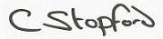

Head of Community

Date: 28/11/2018
P11/18 (a) Location plan

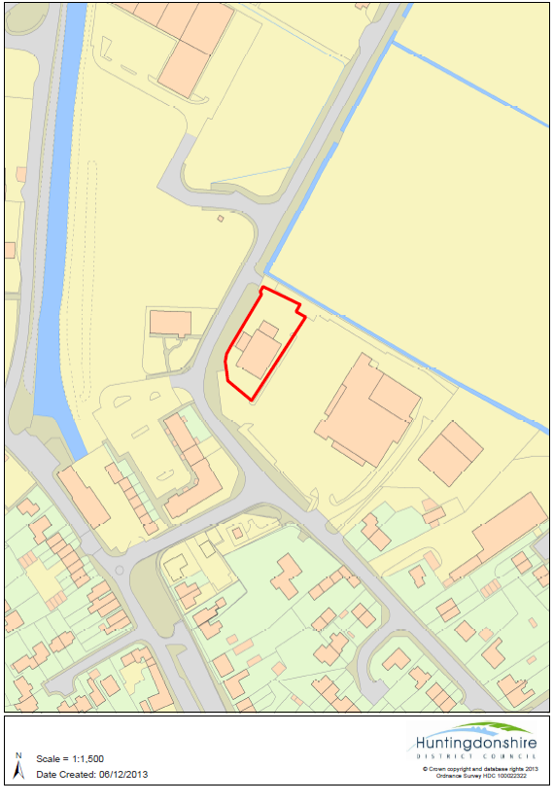

P11/18 (b) Layout plan

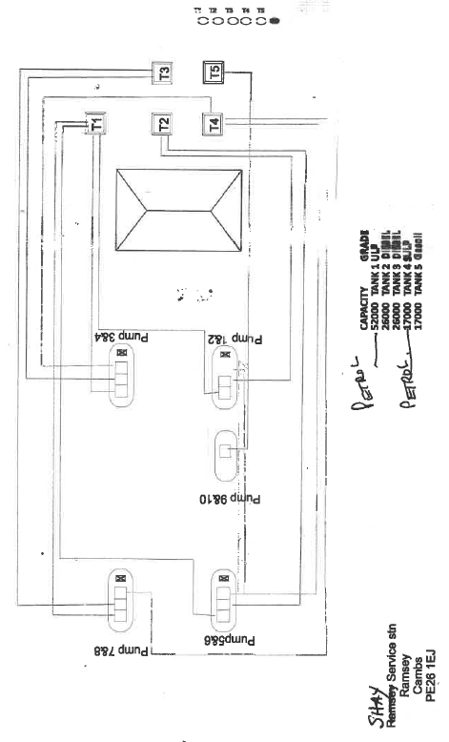

GENERAL NOTES

1 Variation
The regulator will ensure that the permit remains up to date in line with the requirements set out in Regulation 20(1) This may involve issuing a Variation Notice following amendment to the Secretary of State’s Guidance Notes or following receipt of any direction from the Secretary of State.

2 Review of Conditions
The regulator may at any time undertake a review of the conditions in this permit under Regulation 34(1). Where significant pollution is encountered or where there are changes in BAT or where the operational safety of the activity requires other techniques to be used an immediate review shall be undertaken.

3 Appeal
The permitted operator can appeal in writing to the Secretary of State against the items listed in Regulation 31.
Appeals shall be addressed to: | The Planning Inspectorate  Environment Team, Major & Specialist Casework  Room 4/04 Kite Wing  Temple Quay House  2 The Square  Temple Quay  Bristol, BS1 6PN

4 Transfer of Permit
The permitted operator who wishes to transfer the whole or part of the permit to a person who proposes to carry out the activity in the holder’s place may do so in accordance with Regulation 21. Both the operator and the proposed transferee shall jointly make an application to the regulator to effect the transfer. An application shall include the permit and any fee prescribed in respect of the transfer under Regulation 19 and shall contain the operator’s and the proposed transferee’s contact details.

5 Variation of Conditions of Permits
Under Regulation 20, the operator may apply to the regulator to vary the conditions contained within the permit. Such application shall be made in accordance with Part 1 of Schedule 5 and shall be accompanied by any fee prescribed in respect of the application under Regulation 19; and paragraphs 8 of Part 1 of Schedule 5 and paragraphs 5(3) and (4) of schedule 5 shall have effect with respect to such applications.

6 Other Legal Requirements
This permit is issued solely for the purpose of the Pollution Prevention and Control Act and its associated Regulations and the operator must ensure that he complies with all other statutory requirements.

7 Annual Subsistence Charge
The Secretary of State has drawn up a charging scheme under Regulation 19. Under this scheme Local Authorities are required to levy an annual subsistence charge related to the permit. The Local Authority will invoice for the amount due which is subject to annual review by the Department of the Environment Food and Rural Affairs.

